[EE838] Feature Matching and 3D Reconstruction

20164332 Kwanggun Seo / 서광균

Assignment 09 Automatic Computation of Fundamental Matrix

In this assignment, we use 7 point algorithm to compute the Fundamental matrix from the given two images from slightly different view point. In order to do achieve this goal, we use RANSAC a robust optimization method.

Using RANSAC, we can achieve the following advantage and disadvantage. First I will introduce some advantage of RANSAC. Finding Fundamental matrix using RANSAC is a computationally fast operation when there is sufficient amount of inlier matched points. Even if the iteration number is less than exhaustive search, the iteration number increases dramatically as the number of inlier gets smaller. Also, RANSAC does not give a global optimal solution because it is based on the selected data point, and the data point might contain noise from the sensor.

Here are some experiment with different RANSAC parameter changes.

* Inlier Distance

|  |  |  |  |  |  |
| --- | --- | --- | --- | --- | --- |
| Threshold Value | 0.5 | 1 | 1.5 | 5 | 10 |
| Image Set 1 | 22 | 23 | 23 | 34 | 33 |
| Image Set 2 | 217 | 274 | 296 | 329 | 345 |

Table 01. Inlier numbers

|  |  |  |
| --- | --- | --- |
| Threshold Value | 0.5 | 1 |
| Image Set 1 | $$\begin{matrix}-0.00 & 0.00 & -0.0038 \\ -0.00 & 0.00 & 0.0017 \\ 0.0026 & -0.0042 & 1.000\end{matrix}$$ | $$\begin{matrix}-0.00 & 0.001 & -0.00346 \\ -0.00 & -0.00 & 0.0261 \\ 0.0194 & -0.0184 & 0.9987\end{matrix}$$ |
| Image Set 2 |  |  |

|  |  |  |
| --- | --- | --- |
| 1.5 | 5 | 10 |
| $$\begin{matrix}0.00 & -0.00 & -0.0061 \\ 0.00 & 0 & 0.0060 \\ 0.0054 & 0.0088 & 0.9999\end{matrix}$$ | $$\begin{matrix}-0.00 & 0.00 & -0.0037 \\ -0.00 & 0.00 & 0.0015 \\ 0.0029 & -0.0042 & 1.000\end{matrix}$$ | $$\begin{matrix}0.00 & 0.00 & -0.005 \\ -0.00 & 0 & 0.0036 \\ 0.0045 & 0.0063 & 1.000\end{matrix}$$ |
| $$\begin{matrix}0.00 & -0.00 & 0.0009 \\ 0.00 & 0 & -0.0099 \\ -0.0012 & 0.0093 & 0.999\end{matrix}$$ | $$\begin{matrix}0.00 & -0.00 & 0.0011 \\ 0.00 & 0 & -0.0096 \\ -0.0014 & 0.0088 & 0.999\end{matrix}$$ | $$\begin{matrix}0.00 & -0.00 & 0.0012 \\ 0.00 & 0.00 & -0.0103 \\ -0.0013 & 0.0097 & 0.999\end{matrix}$$ |

Table 02. Fundamental Matrix

* iteration is computed using the inlier number at every update.

* feature matching is done using SIFT

As shown in table 1 and 2, as the inlier threshold increases the number of inlier increases. However, in some cases it might not match the relationship due to the nature of random sampling. Also in image set 1, there are not sufficient amount of matched feature point which results in bad estimation.

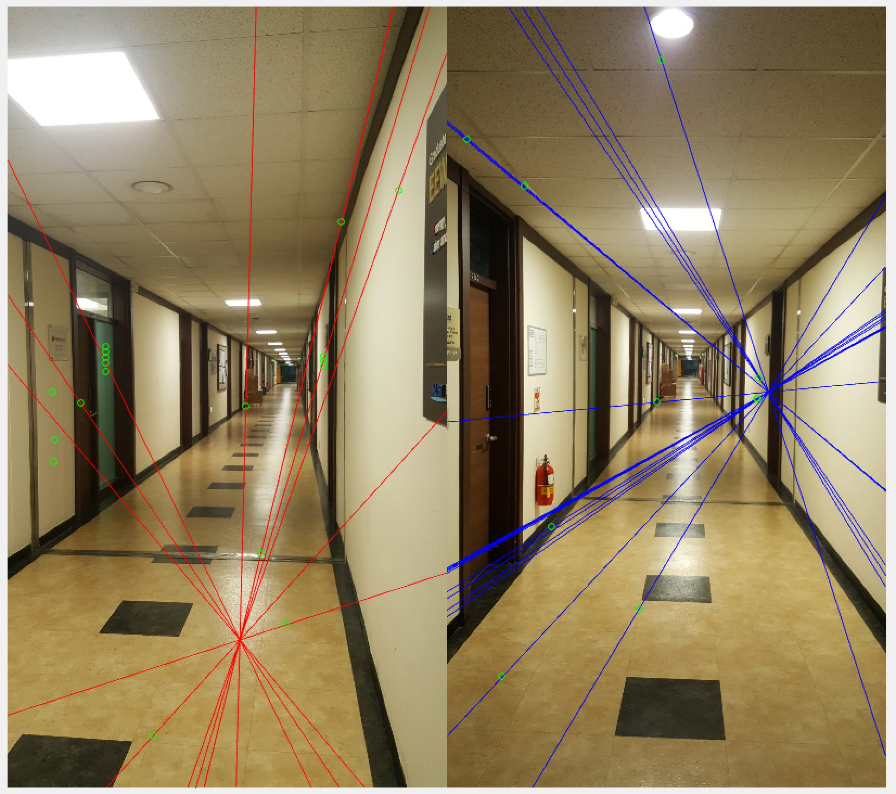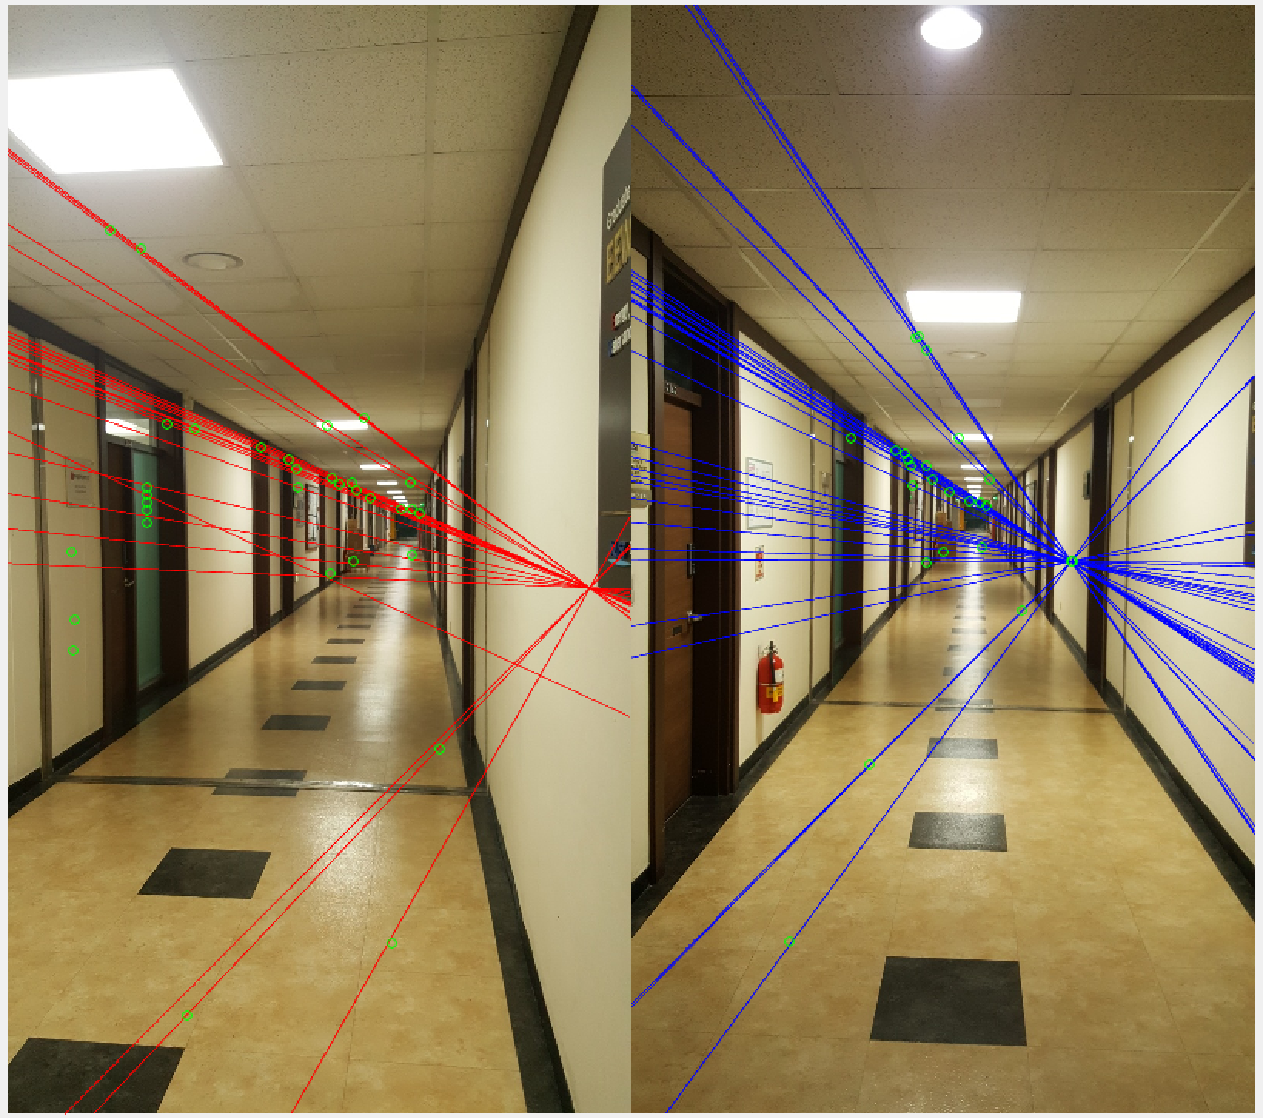

Figure 1. threshold value 0.5 (left) and 5 (right)

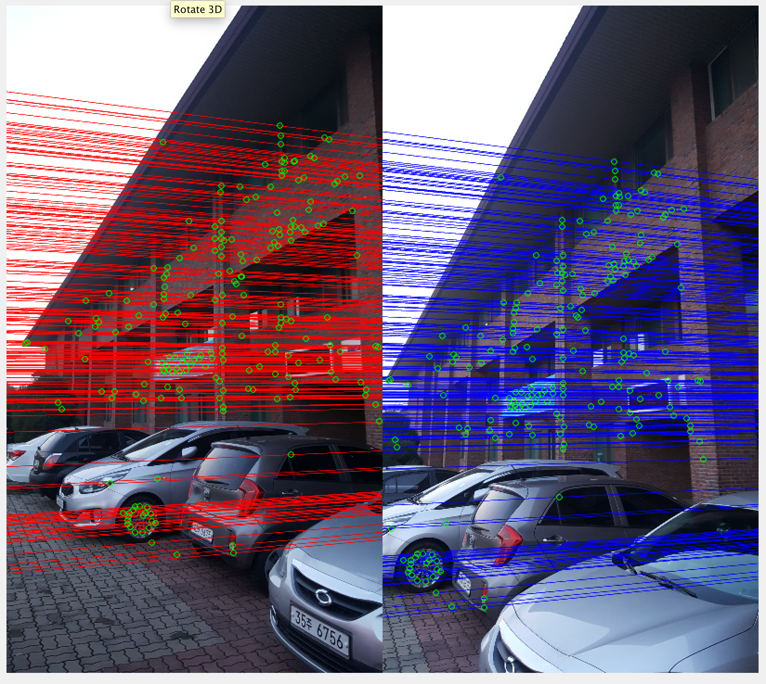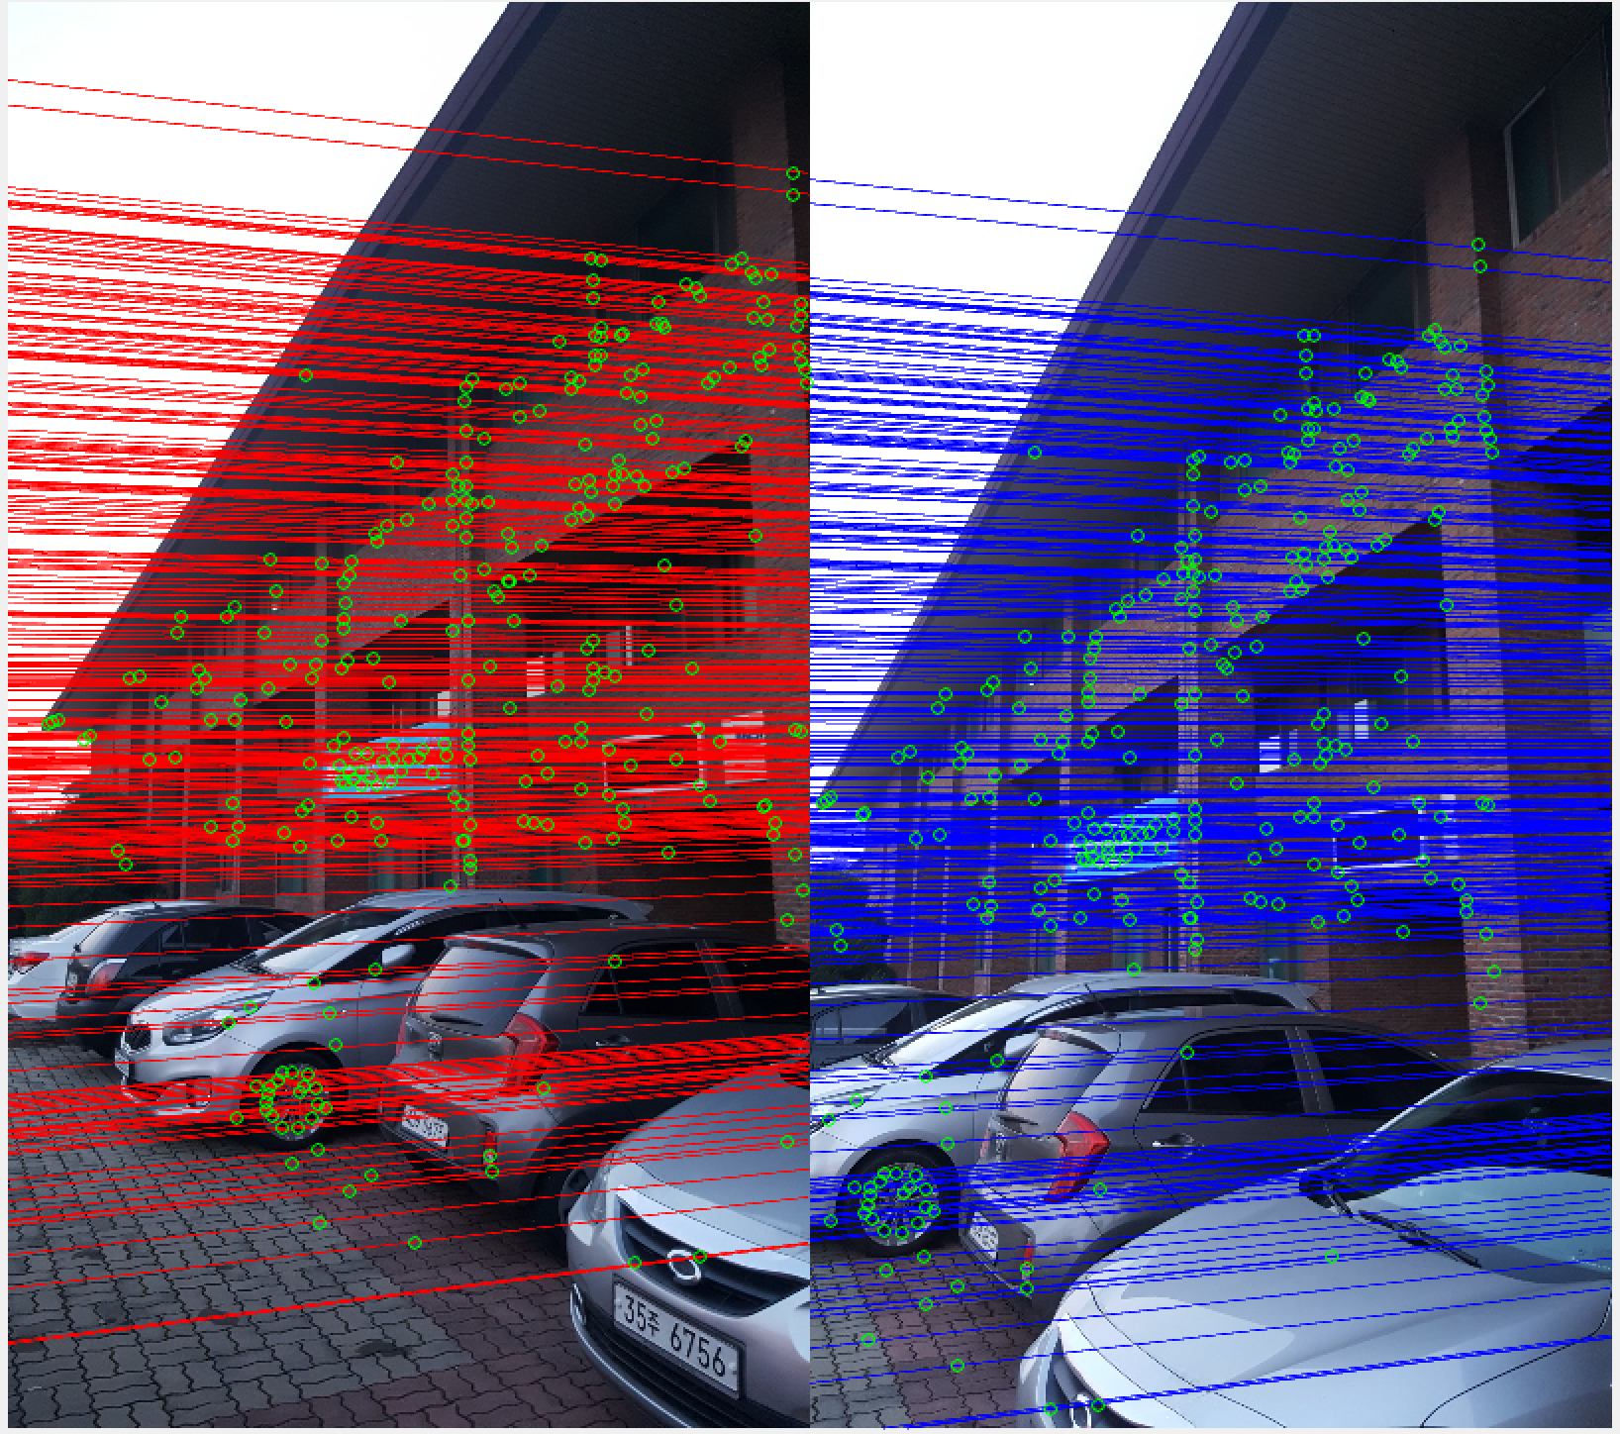

Figure 2. threshold value 0.5 (left) and 5 (right)

* Number of iteration

|  |  |  |  |  |  |
| --- | --- | --- | --- | --- | --- |
| Iteration Number | 10 | 50 | 100 | 1000 | 10000 |
| Image Set 1 | 13 | 19 | 19 | 21 | 25 |
| Image Set 2 | 133 | 208 | 200 | 290 | 291 |

Table 03. Inlier numbers

|  |  |  |
| --- | --- | --- |
| Iteration Number | 10 | 50 |
| Image Set 1 | $$\begin{matrix}0.00 & -0.00 & 0.0021 \\ 0.00 & 0.00 & -0.0009 \\ -0.0037 & -0.0042 & 1.000\end{matrix}$$ | $$\begin{matrix}-0.00 & -0.000 & 0.0024 \\ 0.00 & 0.00 & -0.0033 \\ -0.0032 & -0.010 & 1.000\end{matrix}$$ |
| Image Set 2 |  |  |

|  |  |  |
| --- | --- | --- |
| 100 | 1000 | 10000 |
| $$\begin{matrix}0.00 & -0.000 & -0.0001 \\ 0.00 & -0.00 & -0.0013 \\ -0.0031 & 0.0008 & 1.000\end{matrix}$$ | $$\begin{matrix}0.00 & -0.00 & 0.0009 \\ 0.00 & -0 & -0.0021 \\ -0.0086 & 0.0049 & 0.999\end{matrix}$$ | $$\begin{matrix}-0.00 & 0.00 & -0.0035 \\ -0.00 & 0 & 0.0014 \\ 0.0026 & -0.0040 & 1.000\end{matrix}$$ |
| $$\begin{matrix}0.00 & 0.00 & 0.0042 \\ -0.00 & 0 & -0.0066 \\ 0.0031 & 0.0053 & 1.000\end{matrix}$$ | $$\begin{matrix}0.00 & -0.00 & 0.0011 \\ 0.00 & 0 & -0.0097 \\ -0.0014 & 0.0090 & 0.999\end{matrix}$$ | $$\begin{matrix}0.00 & -0.00 & 0.0011 \\ 0.00 & 0.00 & -0.0097 \\ -0.0014 & 0.0090 & 0.999\end{matrix}$$ |

Table 04. Fundamental Matrix

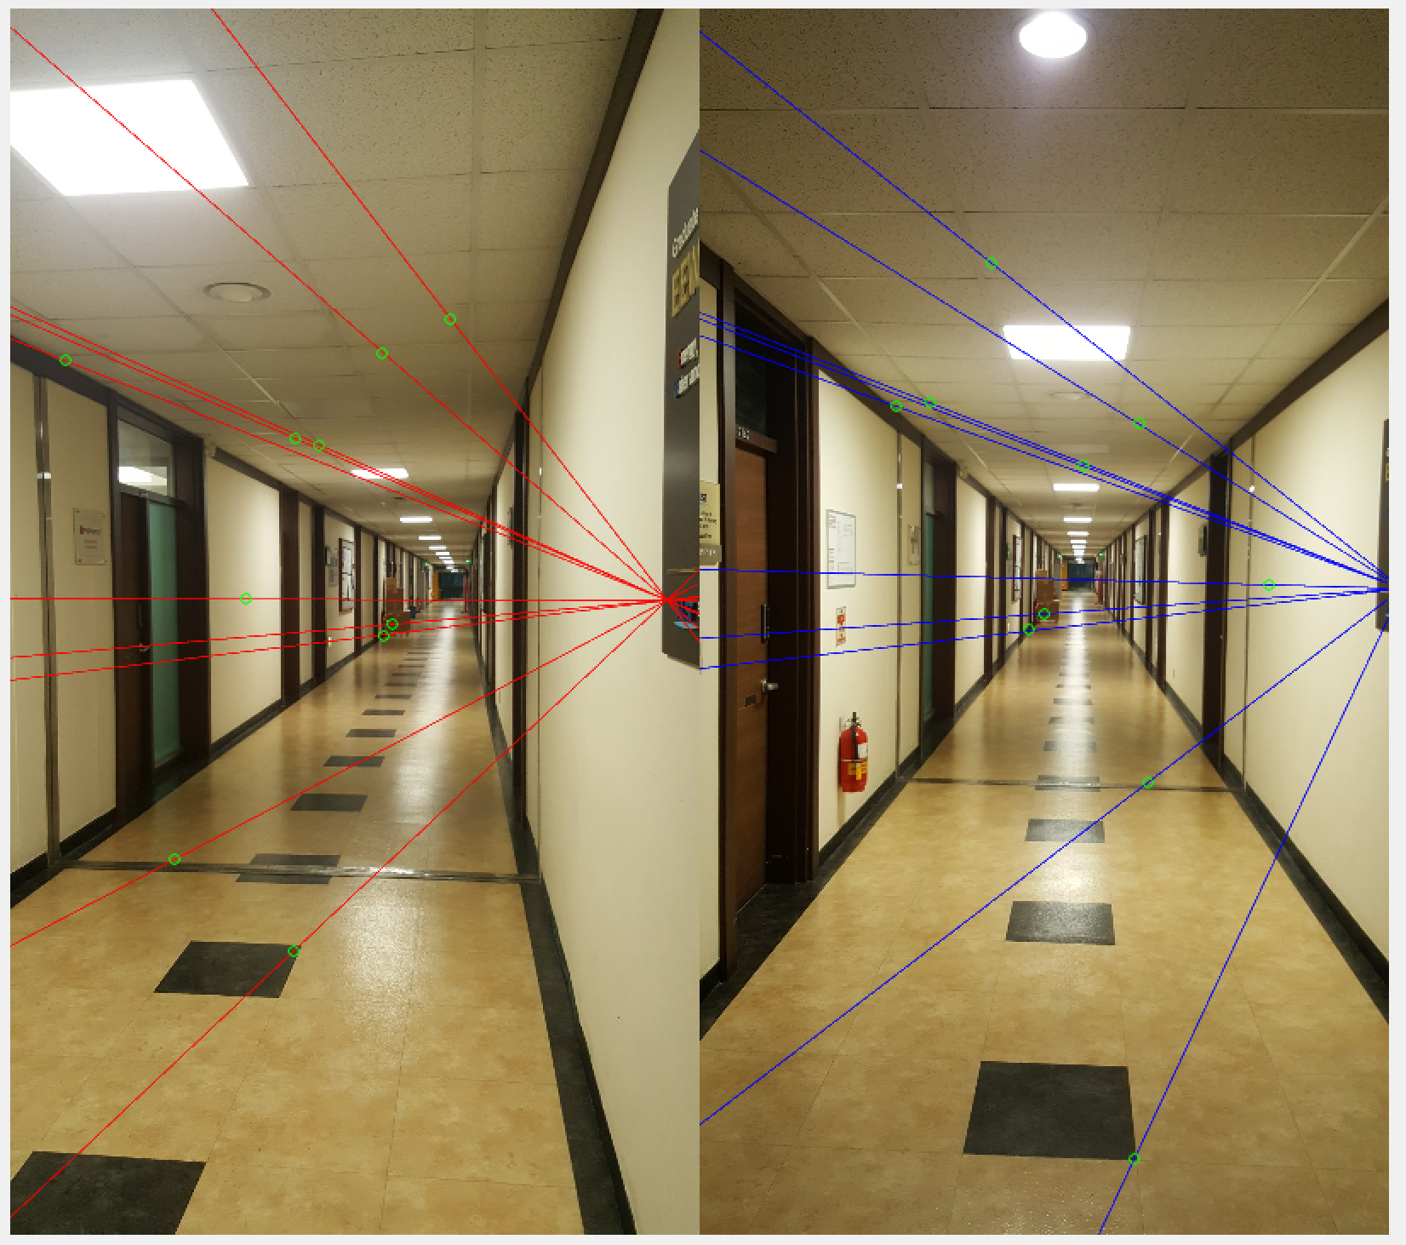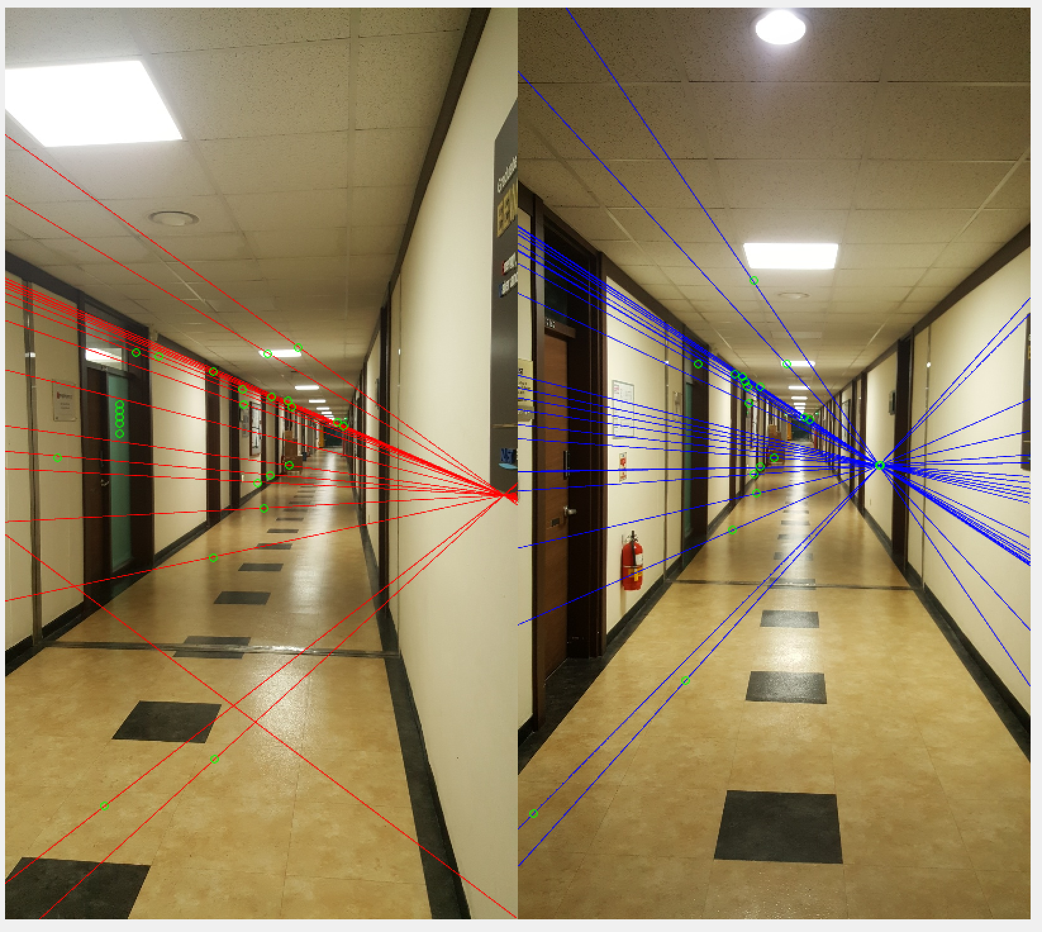

Figure 3. Iteration number 10 (left) and 10000 (right)

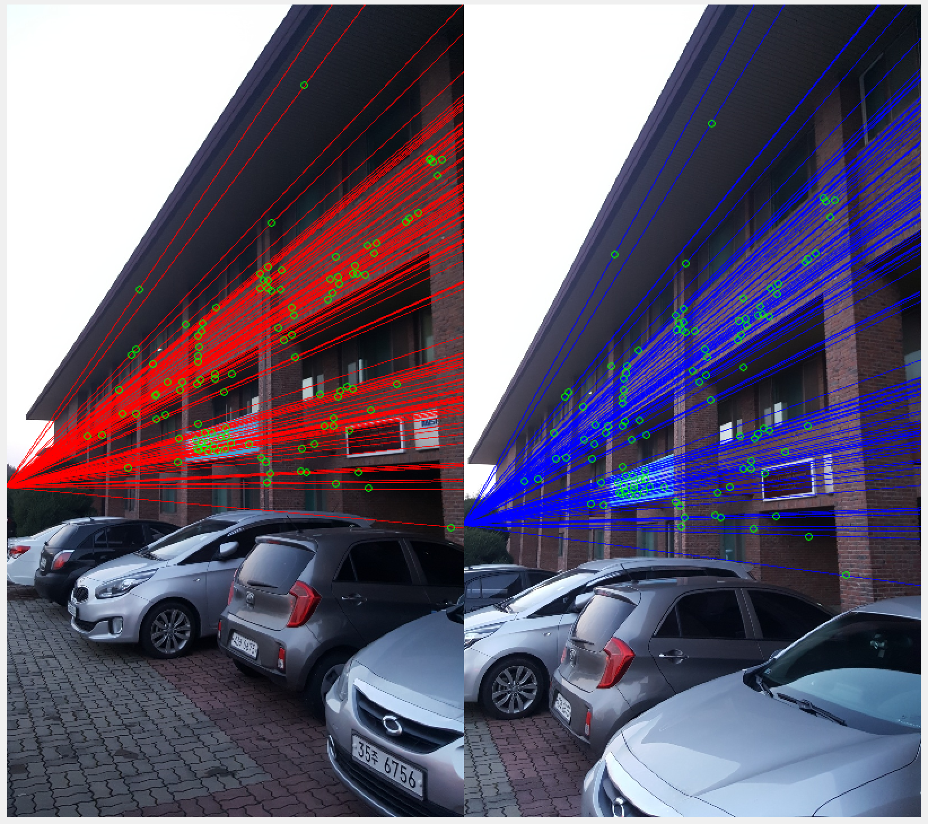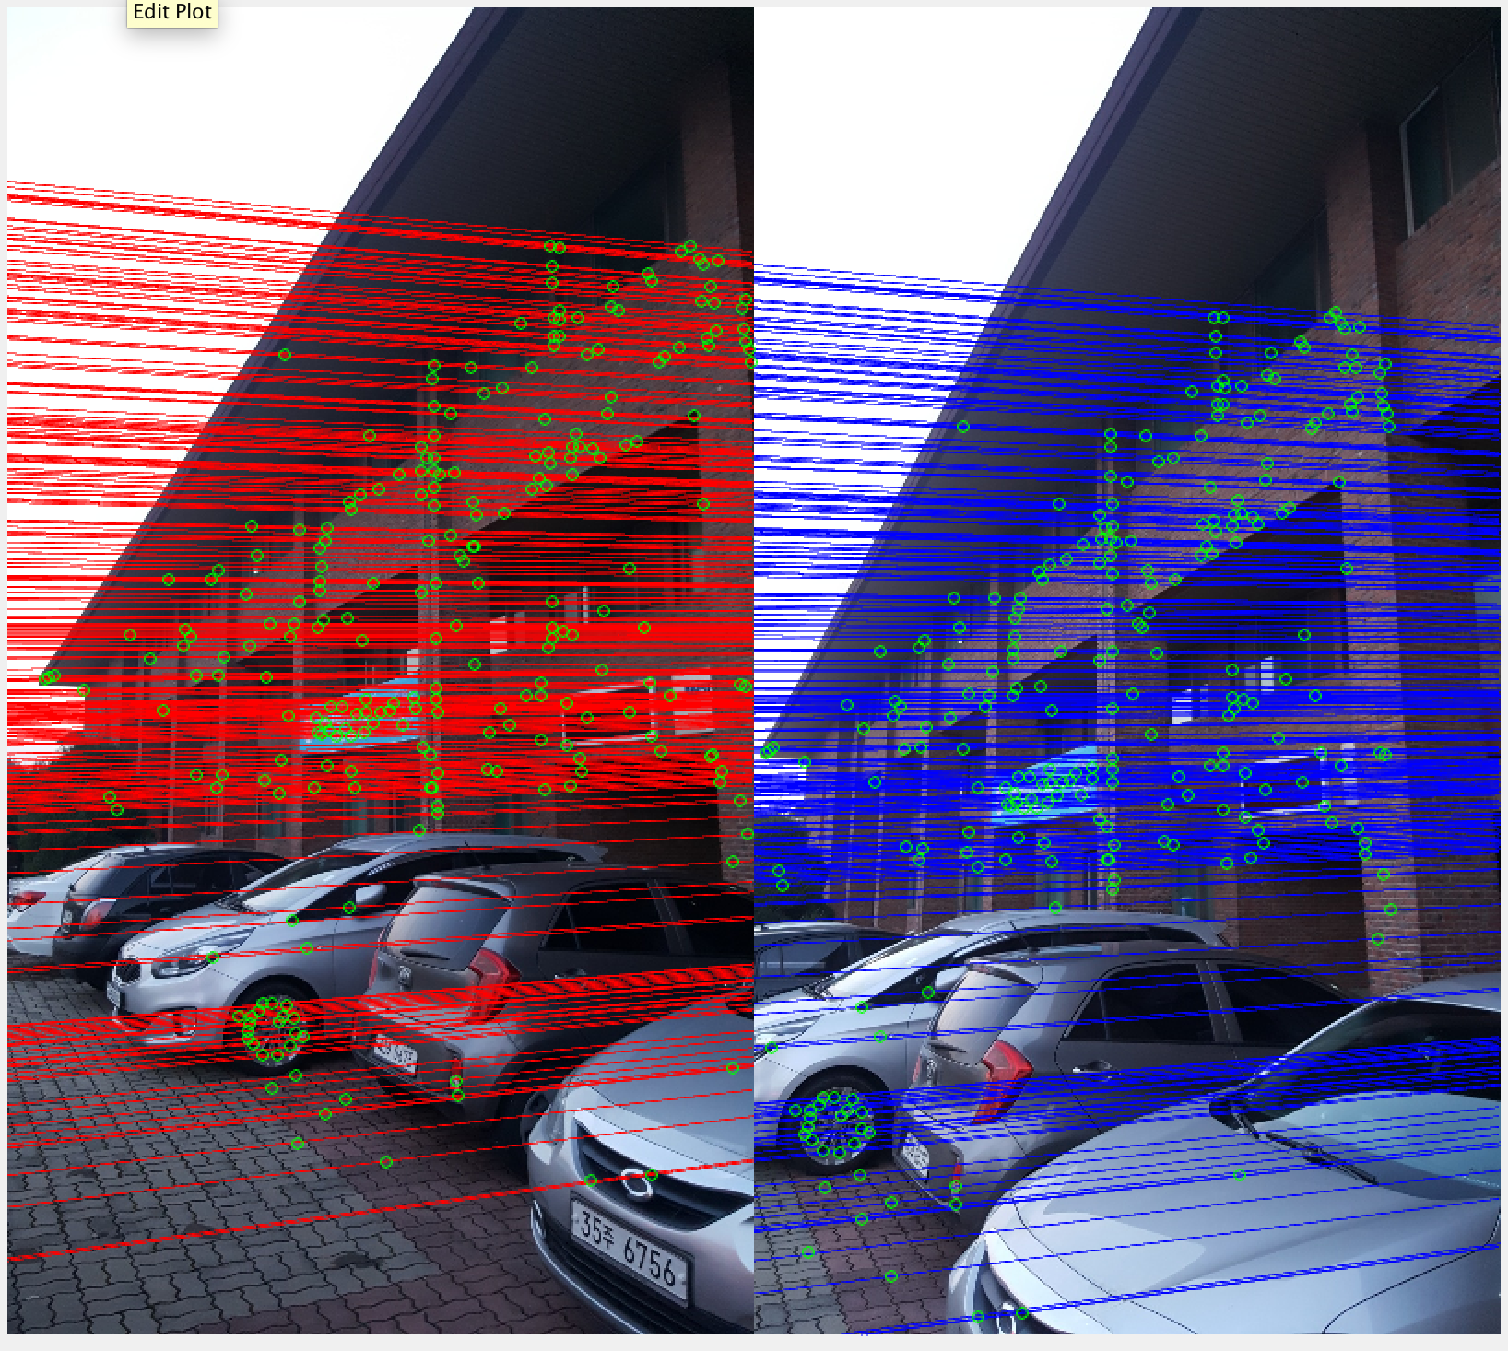

Figure 4. Iteration number 10 (left) and 10000 (right)

As expected, as the number of iteration increases the inlier number increases. However due to nature of random sampling, sometime it might not show the tendency.

[BONUS] Here are some experiment with different feature extraction method

* Harris Corner (NCC matching)

Initial matched result using NCC was not accurate enough to compute the fundamental matrix in image set 1. However it gave inlier number of 12. The second image set gave us 22 inliers. Nonetheless, we can see some mismatched result from the figure 5. This could be due to some error using NCC matching

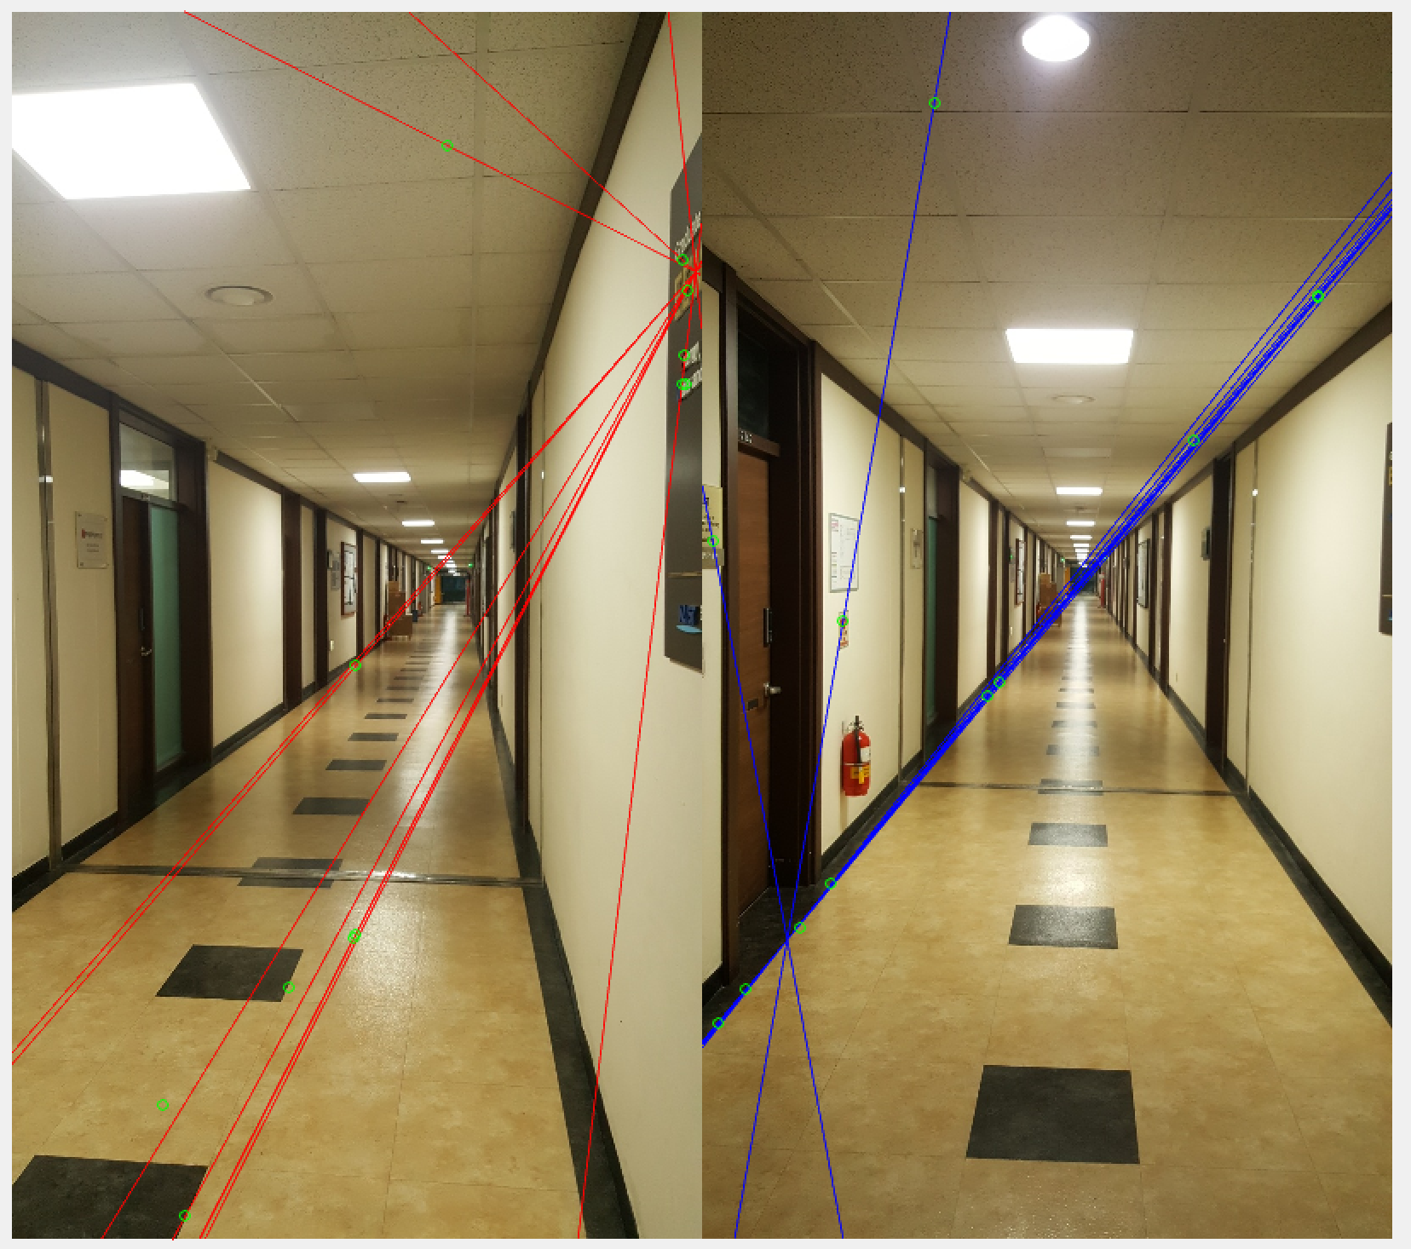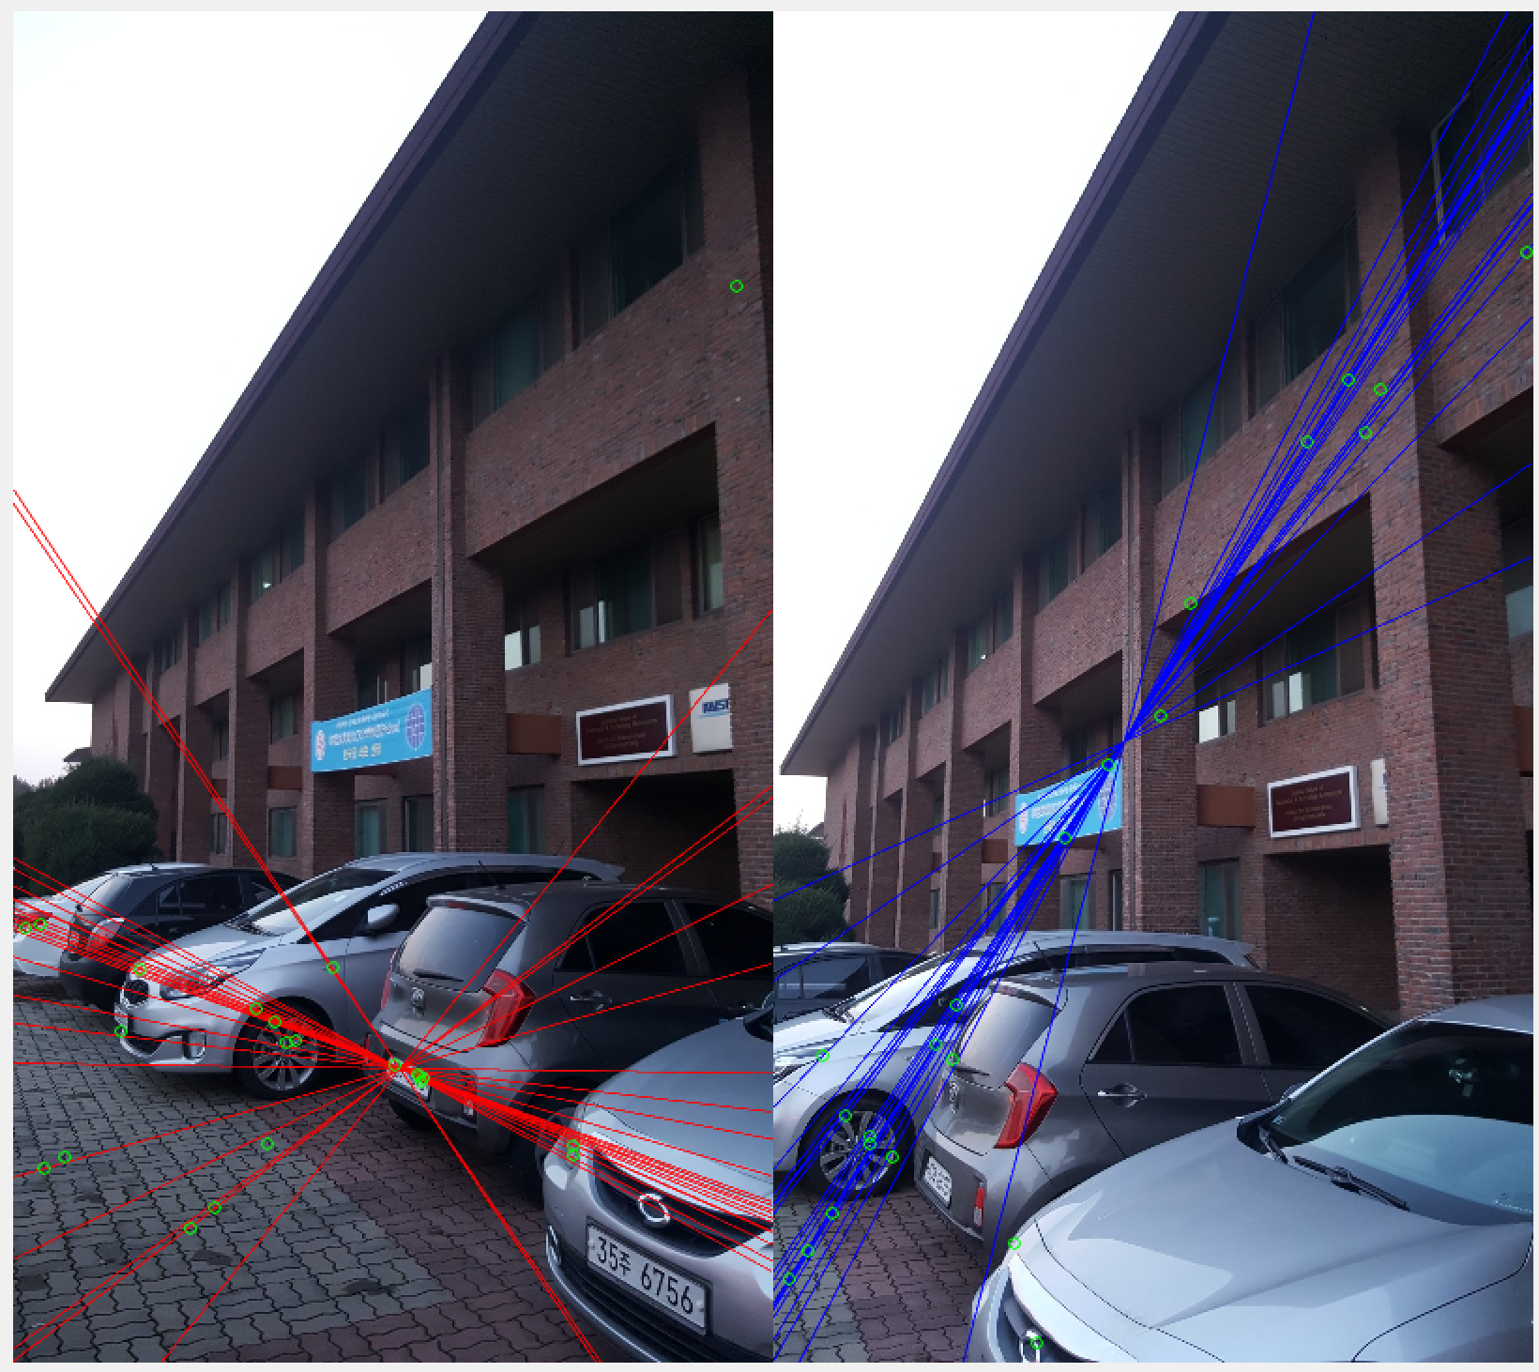

Figure 5. Result using Harris Corner detection and NNC matching